Bahria University,

Karachi Campus



LAB EXPERIMENT NO.

**02**

LIST OF TASKS

|  |  |
| --- | --- |
| TASK NO | OBJECTIVE |
| 1 | Take any integer as input, if the number is greater than 5 print it If a>5, print a ; Else if a=0,then Halt ; Else if a<5 , then Halt. |
| 2 | Take two numbers as input and print the larger number. |
| 3 | Take input from user if A is greater than 5 then print A else terminate the program. |
| 4 | Take two numbers input if a > b then add i.e. c = a + b, else subtract i.e. c = a - b. |
| 5 | Input a number if A is greater than 5 then C = A - 5 otherwise end the program. |
|  |  |
|  |  |
|  |  |

Submitted On:

Date: 12/10/2022

**Task No. 1: Take any integer as input, if a>5, print a ; Else if a=0, then Halt ; Else if a<5 , then Halt.**

**Solution:**

IN

STO 98

SUB 99

BRZ 08

BRP 06

HLT

LDA 98

out

HLT

*99

DAT 005

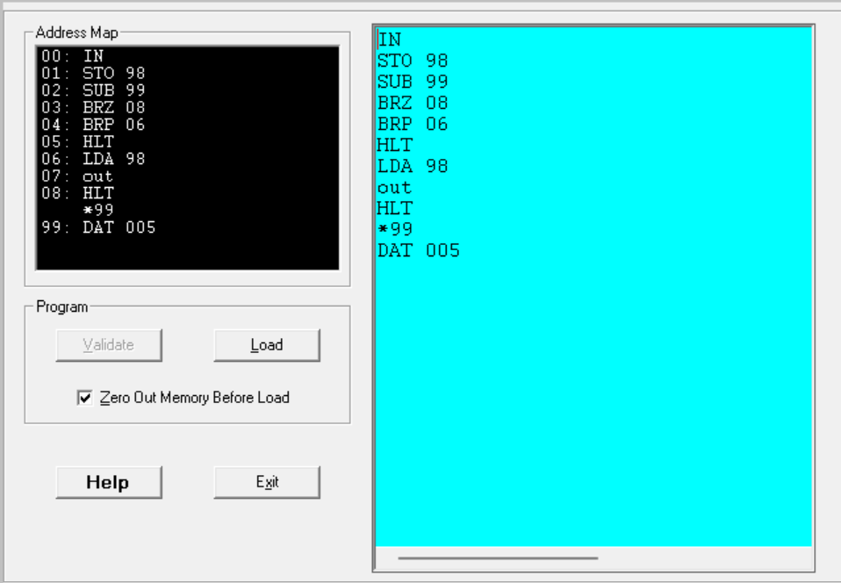**Output:**

**Task No. 2: Take two numbers as input and print the larger number**

**Solution:**

IN

STO 98

IN

STO 99

SUB 98

BRP 09

LDA 98

OUT

HLT

LDA 99

OUT

HLT

**Output:**

**Task No 03: Take input from user if A is greater than 5 then print A else terminate the program.**

**Solution:**

IN

STO 98

SUB 97

BRP 05

HLT

LDA 98

OUT

HLT

*97

DAT 005

**Output:**

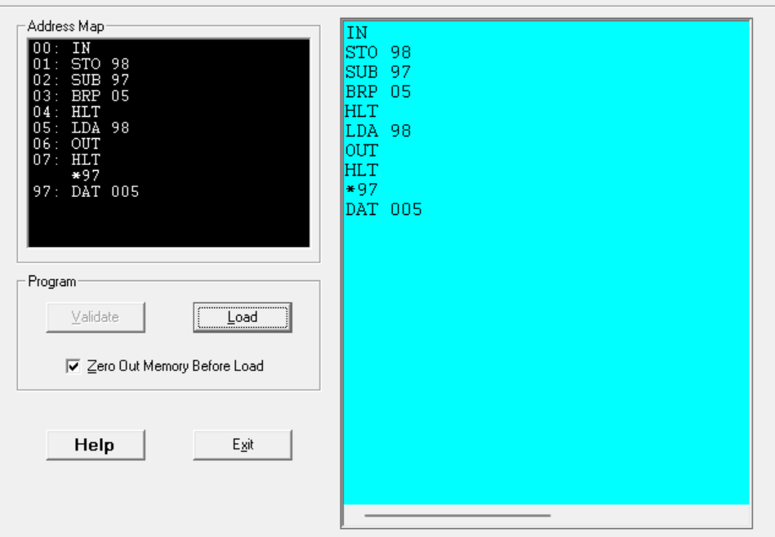

**Task No 04: Take two numbers input if a > b then add i.e. c = a + b, else subtract i.e. c = a - b.**

**Solution:**

IN

STO 97

IN

STO 98

LDA 97

SUB 98

BRP 10

STO 99

OUT

HLT

LDA 97

ADD 98

STO 99

OUT

HLT

**Output:**

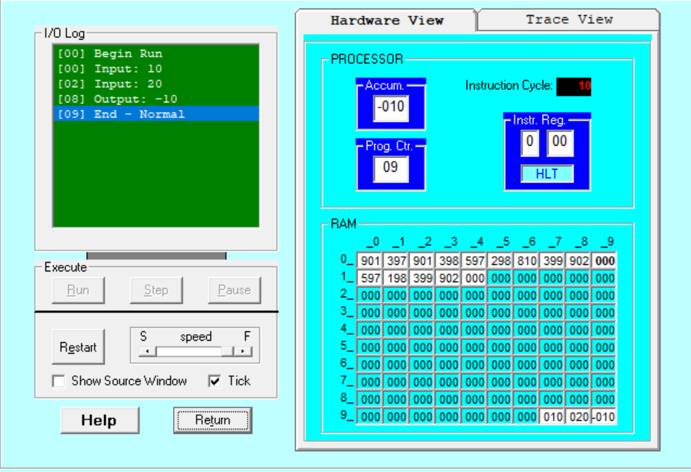

**Task No 05: Input a number if A is greater than 5 then C = A - 5 otherwise end the program.**

**Solution:**

IN

STO 97

SUB 98

BRP 05

HLT

STO 99

OUT

HLT

*98

DAT 005

**Output:**

